- C&C Architectural View type
  - Shared-Data View Packet 1: Buy Item
    - Primary Presentation
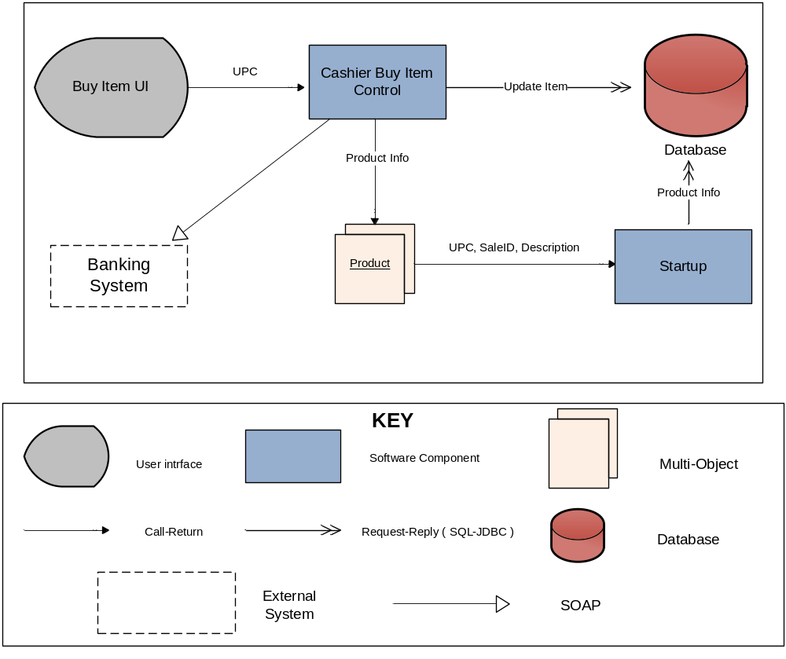-
    - Element Catalog
      - Elements and their properties
Element | Type
Buy Item UI | User Interface
Cashier Buy Item Control | Software Component
Startup | Software Component
Banking System | External System
Product | Object
Database | Database

      - Relationships and their properties
Attachment relation determines which data assessors are connected to which data repositories
      - Element behavior
1) Startup
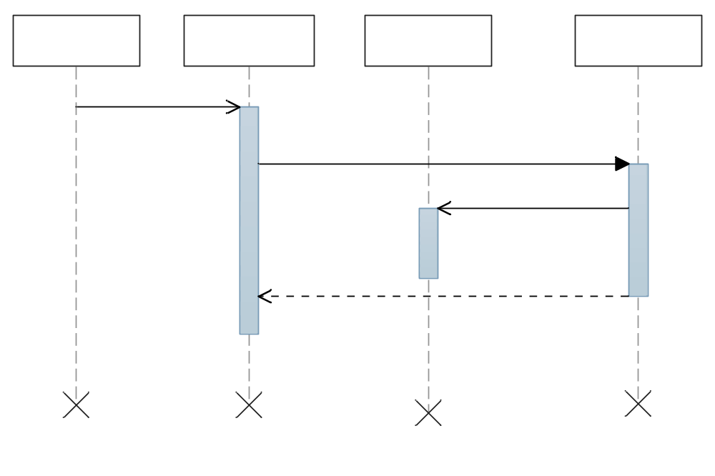

2) Buy Item
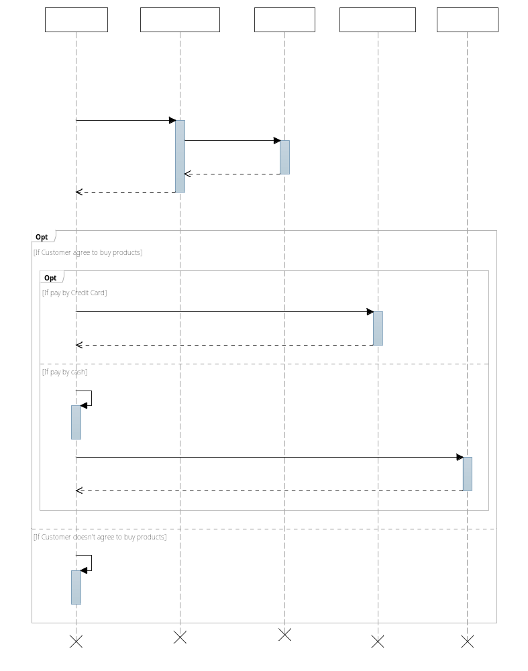

  - Shared-Data View Packet 2: Registries Item ( UCA01 )
    - Primary Presentation
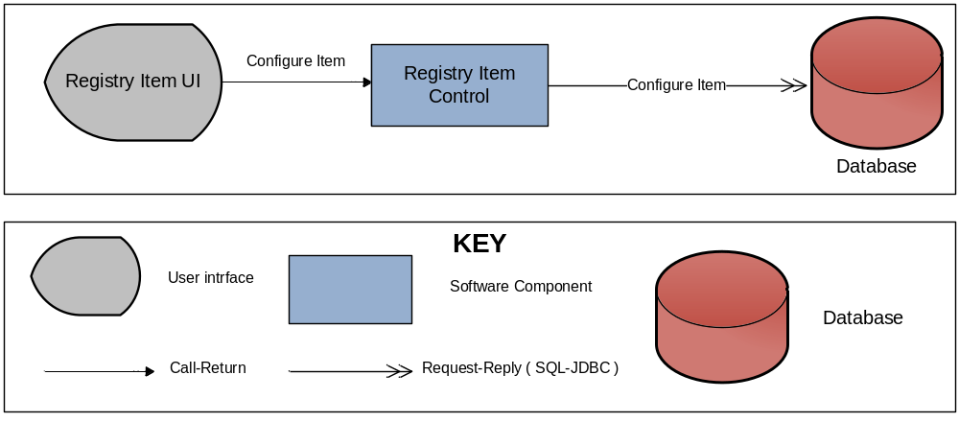

    - Element Catalog
      - Element and their properties
Element | Type
Registry Item UI | User Interface
Registry Item Control | Software Component
Database | Database

      - Relationships and their properties
Attachment relation determines which data assessors are connected to which data repositories

    - Architecture Background
      - Design Rational

The rational for this decomposition is to further divide into 2 software component: GUI and Control (connect to Server). It will guarantee modifiability

The rational for calling inventory to receive sales history in purchase entity from database:
- MySQL complies each product to administrator can add or remove items. So we will precompiled, so result in tremendous performance boots when stored product are called repeatedly

  - Shared-Data View Packet 3: Registries Cashier ( UCA02 )
    - Primary Presentation
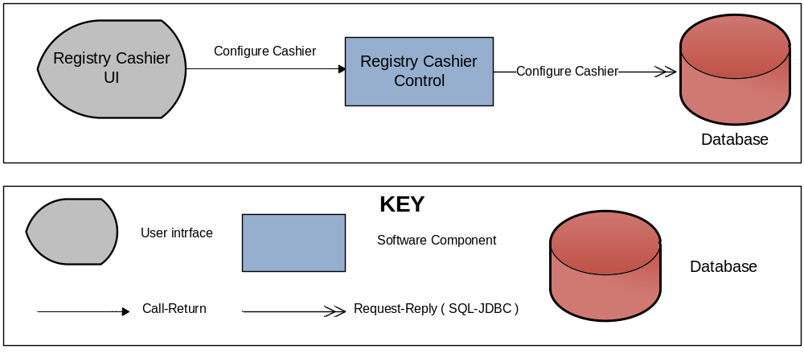
    - Element Catalog
      - Element and their properties
Element | Type
Registry Cashier UI | User Interface
Registry Cashier Control | Software Component
Database | Database

      - Relationships and their properties
Attachment relation determines which data assessors are connected to which data repositories
      - Element Behavior

